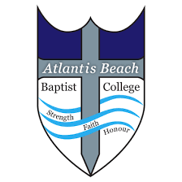
Atlantis Beach Baptist College

Dear Parents/Guardians,
Permission slip for Year 10 Students to attend the Skills West Careers and Employment Expo at the Perth Convention and Exhibition Centre on Thursday, 25 July 2024.

I, ______________________________, the parent of ____________________________,
 give consent for my child to attend the Skills West Careers and Employment Expo at the Perth Convention and Exhibition Centre on Thursday, 25 July 2024.
 do not give consent for my child to attend the Skills West Careers and Employment Expo at the Perth Convention and Exhibition Centre on Thursday, 25 July 2024.
(Please tick appropriate box)

Signed: ____________________________________ Date: ___________________

Sincerely,
Mrs. Tracy-lee Fick
Deputy Principal

